Angular Material

-provides a set of reusable, well-tested, and accessible UI component based on material design

-UI component framework and reference implementation of Google’s Material Design specification

Node JS

-open source cross platform runtime environment to get the tools that we need

-can leverage npm,

Key Principles

-Material is the metaphor

-Meaningful Transition

Getting Started

Tsc –version //4.7.2



Typography: style and appearance of printed matter

-This gives us access to a lot of classes responsible for spacing, shadows, animations

-Selecting yes will add mat-topography classes to our index.html



Move to style file

Importing all these mat modules can be cumbersome

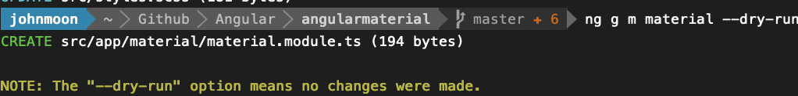

--dry-run will let us see where it will locate the file

--flat means don’t make a file

material.module.ts

-exports all of Mat then import it to app

Layout Components



-adds routing



-just generates the component

7. Using Data Tables

Arrays

-most limited

-need to explicitly trigger an update by calling an update method

Observable stream

-emits data array to be rendered each time it is changed

DataSource

-for complex most recommended